Anexo 01
 | System Information
 | System Voltage |  |  | 22,900 |  |  | V
 | Upstream Overcurrent Breaker (device) |  |  | 117 |  |  | A
 | Short Circuit Current (Isc) |  |  | 7.6 |  |  | kA
 | Energy Storage (e.g. Capacitors) |  |  | 0.0 |  |  | kJ
 | Opening Time |  |  | 0.10 |  |  | Sec
 | Working Distance (From the arc source) |  |  | 910 (36 in) |  |  | (*)
 | Power - For Arc Flash prot. Boundaries |  |  | 4,640.5 |  |  | kVA (*)
 | (*) Fixed or Automatic Value
 | Incident Energy |  |  | 10.7 |  |  | cal/cm2
Análisis de seguridad eléctrica

(imagen PPE) Ej:

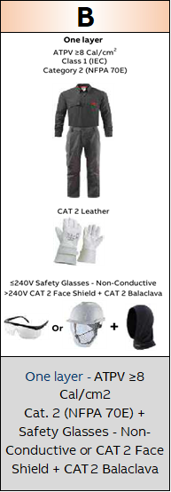
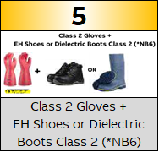
Frontera de protección de arco y choque eléctrico
Distancias para instalación de barricada durante verificación de Seven Steps y señalización perimetral

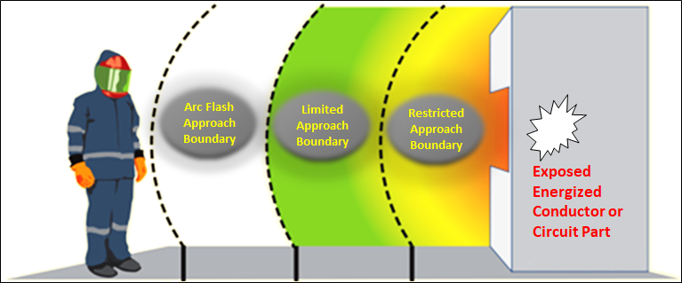
According to NFPA70E: Table 130.4(E)(a)

 |  |  | 1.5 m |  | 1.8 m | 0.8 m
 |  |  |  |  | 3 m
 |  |  |  |  | ñ
Exposed Movable Conductor

Etiqueta NFPA70E
Etiqueta para imprimir y colocar en el área de trabajo

 |  |  |  | WARNING
 |  |  |  | Arc Flash & Shock Hazard  Appropriate PPE Required
 | ARC FLASH PROTECTION BOUNDARY AND REQUIRED PPE |  |  |  |  |  |  |  | ABB Electrical Safety Calculator V1.6a Jan. 2024
 | Arc Flash boundary: |  | 0.1 m |  |  | Glove Class/ CAT: | Class 1 ≥7.5kV + CAT 3 Leather |  | ABB Electrical Safety Calculator V1.6a Jan. 2024
 | Required PPE: |  | Multi-layer mandatory ATPV ≥8 Cal/cm2 and ATPV ≥25 Cal/cm2 + Ear Prot. + CAT 3 Complete Hood |  |  | Footwear: | Electrical Hazard Footwear “EH” |  | ABB Electrical Safety Calculator V1.6a Jan. 2024
 | SHOCK HAZARD PROTECTION BOUNDARIES |  |  |  |  |  |  |  | ABB Electrical Safety Calculator V1.6a Jan. 2024
 | Shock Hazard: |  | 122 VAC |  |  |  |  |  | ABB Electrical Safety Calculator V1.6a Jan. 2024
 | Limited Approach: |  | 1m |  |  | Restricted Approach: | 0.3 m |  | ABB Electrical Safety Calculator V1.6a Jan. 2024
 | Bus/Equipment ID: |  | SE PACHACAMAC 10 KV |  |  | Assessment Date: | 2026/01/09 |  | ABB Electrical Safety Calculator V1.6a Jan. 2024
 | Protective Device (Upstream): |  |  | SALA TR2 |  |  |  |  | ABB Electrical Safety Calculator V1.6a Jan. 2024
 | THIS LABEL IS FOR TEMPORARY USE AND MUST BE REMOVED AFTER SERVICE IS COMPLETED
 | IMPORTANT: This label was generated using estimated values ​​and may be used in the absence of a formal arc flash risk assessment.

